**“CardCreator “– Creating business cards with Java GUI**

* **Features**

CardCreator is a powerful JavaFX and Java Swing application, that allows user to:

* Create cards using interactive and easy ✨stylised✨ GUI
* Saving and exporting as PNG
* Adding various amount images
* Adding all needed types of information (Company name, Title, Logo, etc.)

And much more will come if will be needed and there will be time for that…

* **Screenshots**
* **Interface:**

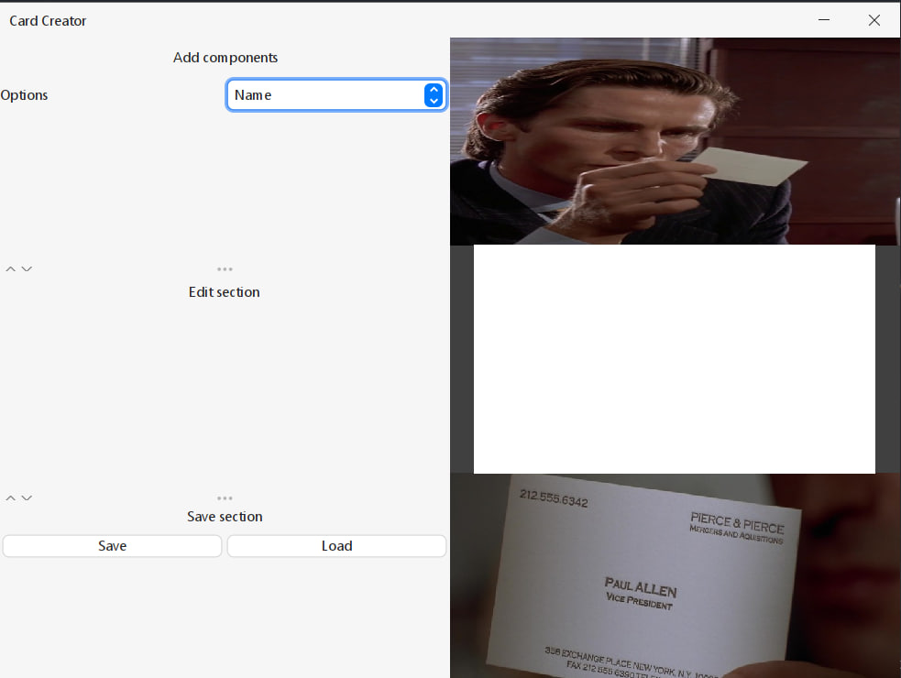

Obr. 1 This is how looks starting window.

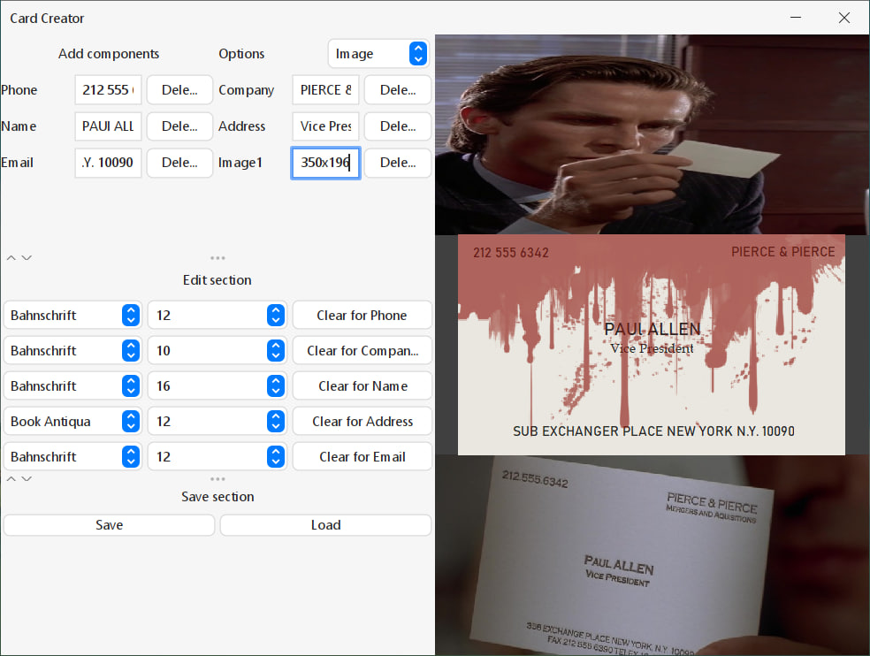

Obr. 2 This is how it looks in work.



Obr. 3 And this is how looks the final PNG result.

* **Edit possibilities:**

`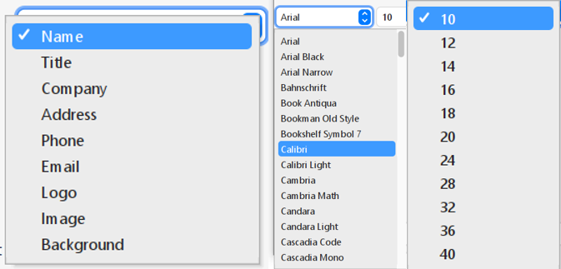

* **Aftermath:**



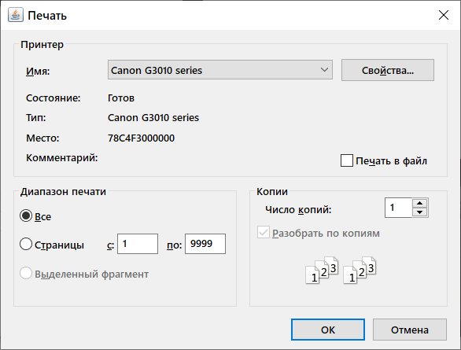

Obr. 4 Printing



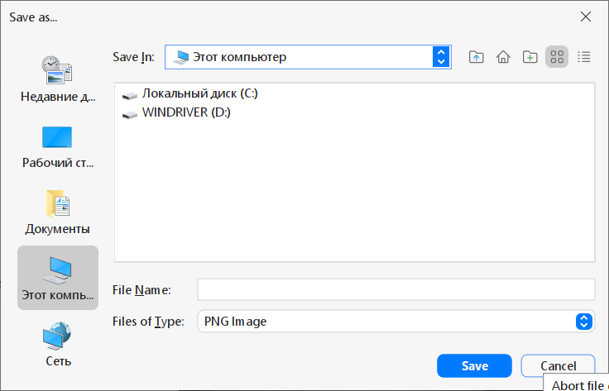

Obr. 5 Saving

Obr. 6 And also saving in format, that can be loaded later as project

(but loading is not implemented yet)

* **Excuses:**

Though, the loading is not working (yet!!), it at least prints out information about components)

For example, for this card:

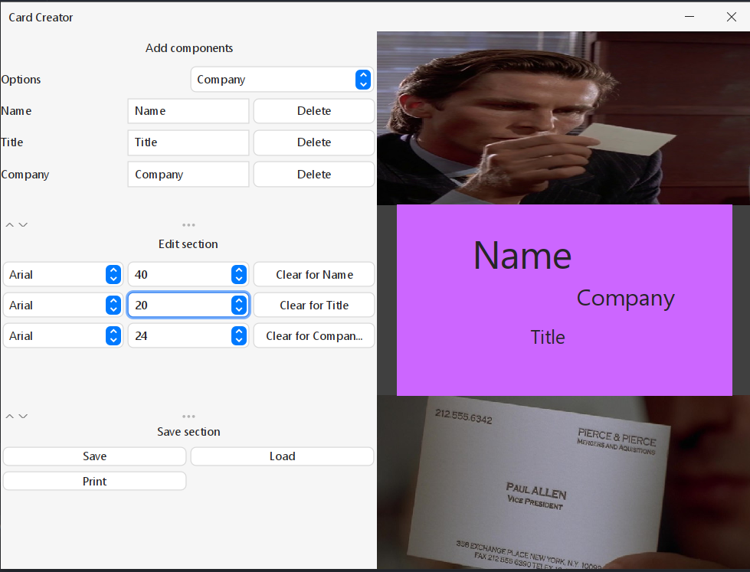

will be loaded and will look like this in console:

*“Card saved successfully as card.dat”*

*“****BusinessCard****(components=[****CardComponent****(type=label, text=Title, image=null, position=java.awt.Point[x=139,y=124], size=java.awt.Dimension[width=37,height=27], color=javax.swing.plaf.ColorUIResource[r=38,g=38,b=38], font=java.awt.Font[family=Segoe UI,name=Segoe UI,style=plain,size=20]),* ***CardComponent****(type=label, text=Company, image=null, position=java.awt.Point[x=188,y=80], size=java.awt.Dimension[width=102,height=32], color=javax.swing.plaf.ColorUIResource[r=38,g=38,b=38], font=java.awt.Font[family=Segoe UI,name=Segoe UI,style=plain,size=24]),* ***CardComponent****(type=label, text=Name, image=null, position=java.awt.Point[x=78,y=24], size=java.awt.Dimension[width=105,height=54], color=javax.swing.plaf.ColorUIResource[r=38,g=38,b=38], font=java.awt.Font[family=Segoe UI,name=Segoe UI,style=plain,size=40])])”*

* **Tech**
* [JavaFX, Java Swing] - for building the graphical user interface
* [Lombok] – for generating Getters/Setters/ToString/etc. methods in code
* **Running the application**

To run the CardCreator application you need to double click on the CardCreator.jar file in src folder of the project.